LIST OF FUNCTIONALITIES AND WHAT IT HAVING AND WHAT IS NOT HAVING.

Creating an Elderly Companion Network app is a wonderful idea, addressing the crucial issue of loneliness among seniors. Here's a breakdown of features for both the elderly person and caretaker interfaces:

Elderly Person Interface:

Profile Setup:

Allow seniors to create profiles with information about their interests, hobbies, and any specific needs or preferences they may have.

Companion Matching:

Implement a matching algorithm to connect seniors with suitable companions based on shared interests, availability, and proximity.

Appointment Scheduling:

Enable seniors to schedule companionship sessions, assistance with chores, or transportation services through the app.

Emergency Assistance Button:

Include an emergency button that seniors can press to quickly alert their designated caretaker or emergency services in case of need.

Feedback and Ratings:

Provide a rating and feedback system to allow seniors to rate their companions, ensuring a positive experience and helping improve the service.

Chat and Communication:

Include a secure chat feature for easy communication between seniors and their assigned companions.

Event Calendar:

Allow seniors to view and participate in local community events, gatherings, or virtual meetups to further encourage social engagement.

Reminders and Notifications:

Implement reminders for appointments, medication schedules, and other important events.

Caretaker Interface:

Registration and Verification:

Ensure caretakers undergo a thorough registration and verification process, including background checks to ensure the safety of the seniors.

Companion Matching Dashboard:

Provide a dashboard that displays available requests from seniors, allowing caretakers to choose companionship opportunities based on their availability and skills.

Schedule Management:

Include a calendar to manage upcoming appointments, track completed sessions, and plan their availability for future companionship opportunities.

Emergency Response System:

Integrate a system that allows caretakers to receive alerts in case of emergencies or urgent needs from the seniors they are assisting.

Communication Hub:

Incorporate a messaging system to facilitate communication between caretakers and seniors. This can include updates on activities, schedules, and any changes in plans.

Feedback and Improvement:

Provide a platform for caretakers to receive feedback from both the seniors and the app administrators. This helps in continuous improvement and ensures the quality of service.

Training and Resources:

Offer training materials and resources for caretakers to enhance their skills in providing companionship, assistance, and understanding the needs of elderly individuals.

Community Support Forum:

Establish a forum where caretakers can share experiences, seek advice, and build a supportive community among themselves.

Remember to prioritize user-friendly design, accessibility, and security, especially when dealing with the elderly population. Regularly update the app based on user feedback and changing needs in the community.

\*Care Taker Application.

Application that connects the cared person and company.

**Company Functionality:**



User Functionality:

* Creating request for service.

. The responsibility of this partnership ideally is shared between you, the caregiver, the GP and other healthcare staff. However, it will often fall to you to be assertive, using good, to ensure that everyone's needs are met - including your own.

Stand alone the App of care teker.

Both side of client of Civer and Taker.   
  
Interface of disabled person and caretaker   
  
https://www.capterra.com/p/140368/Carecenta/

https://www.capterra.com/p/163319/StoriiCare/  
Web and Mobile.

https://www.capterra.com/p/124471/ContinuLink/  
Web and Mobile

Shift management and customer holding system.

Mobile applications are having the information that taken and reports that made by Worker.   
The Person of care has not option of asking for tasks and check of health condition at a time.

Companies in Limerick:   
  
\* <https://www.seniorandelderlycare.ie/Limerick/Elderly%20Care.html>  
  
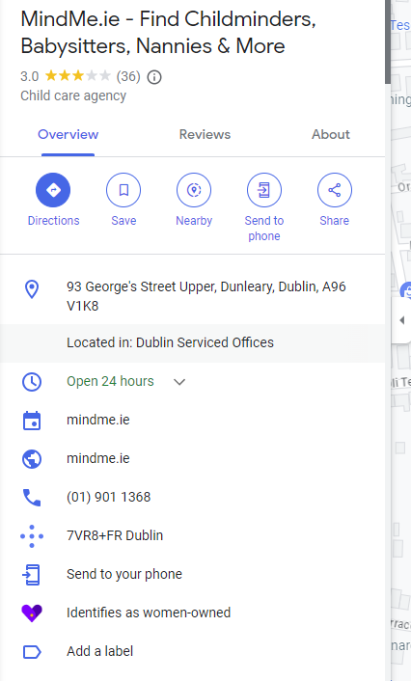

\*

**BLUE BIRD CARE.**

<https://www.bluebirdcare.ie/limerick>

##### What if I don't like my care package or want to make changes?

Our experience tells us that people's care needs very often change. We therefore understand that care may need reviewing from time to time. This is why we carry out reviews on a regular basis and why we are pleased to hear from members of the immediate family about effective methods for delivering the care service for their relative.   
  
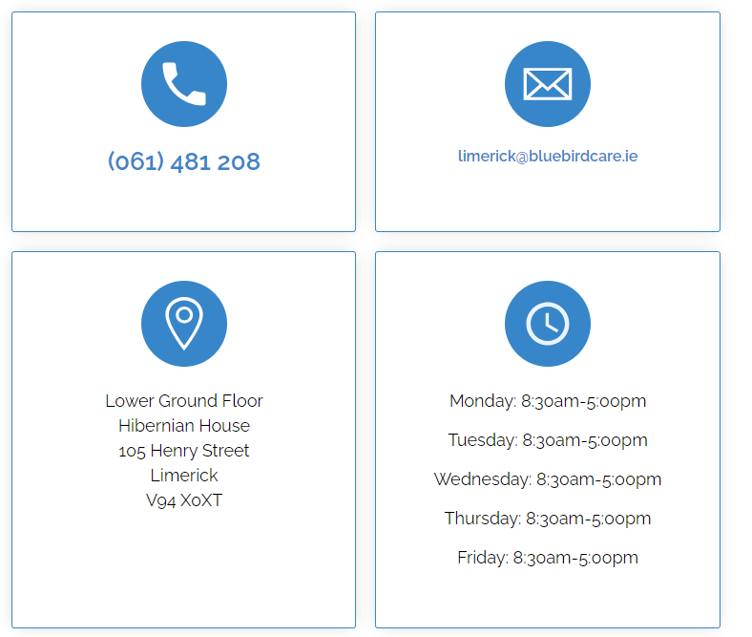

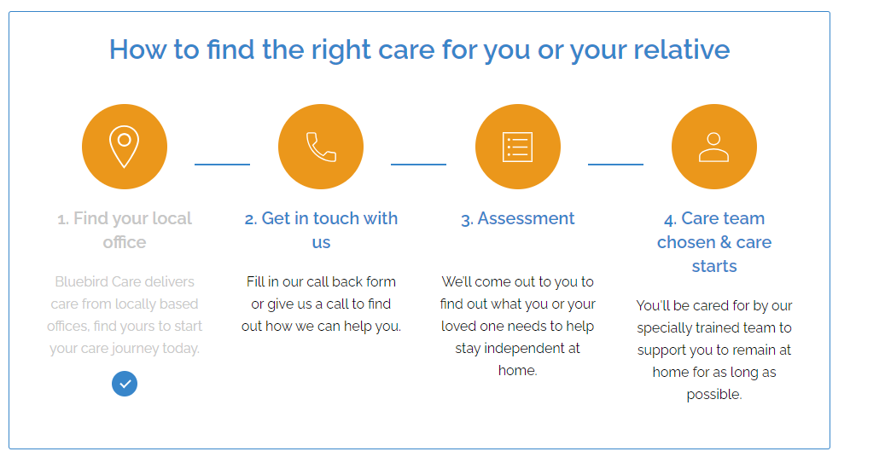

Registration for application only online and no availability for feedback from users.

NO MOBILE APP.

\*  
  
<https://www.homeinstead.ie/live-in-care>  
  
  
061462070  
  
Fairgreen, Ballysimon Rd, Singland, Limerick  
  
  
  
\*  
https://www.carebright.ie/

Limerick City

CareBright,  
1st Floor, Unit 7,  
Ballycummin Village, Raheen,  
Limerick, V94 K857

Tel: [061 602700](tel:061%20602700)  
Mob: [087 6902842](tel:087%206902842)

* Care.com Marketplace of caretaking   
    
  <https://www.care.com/en-ie/profiles/elderly-care/limerick>

https://play.google.com/store/apps/details?id=com.care.android.careview.providerapp

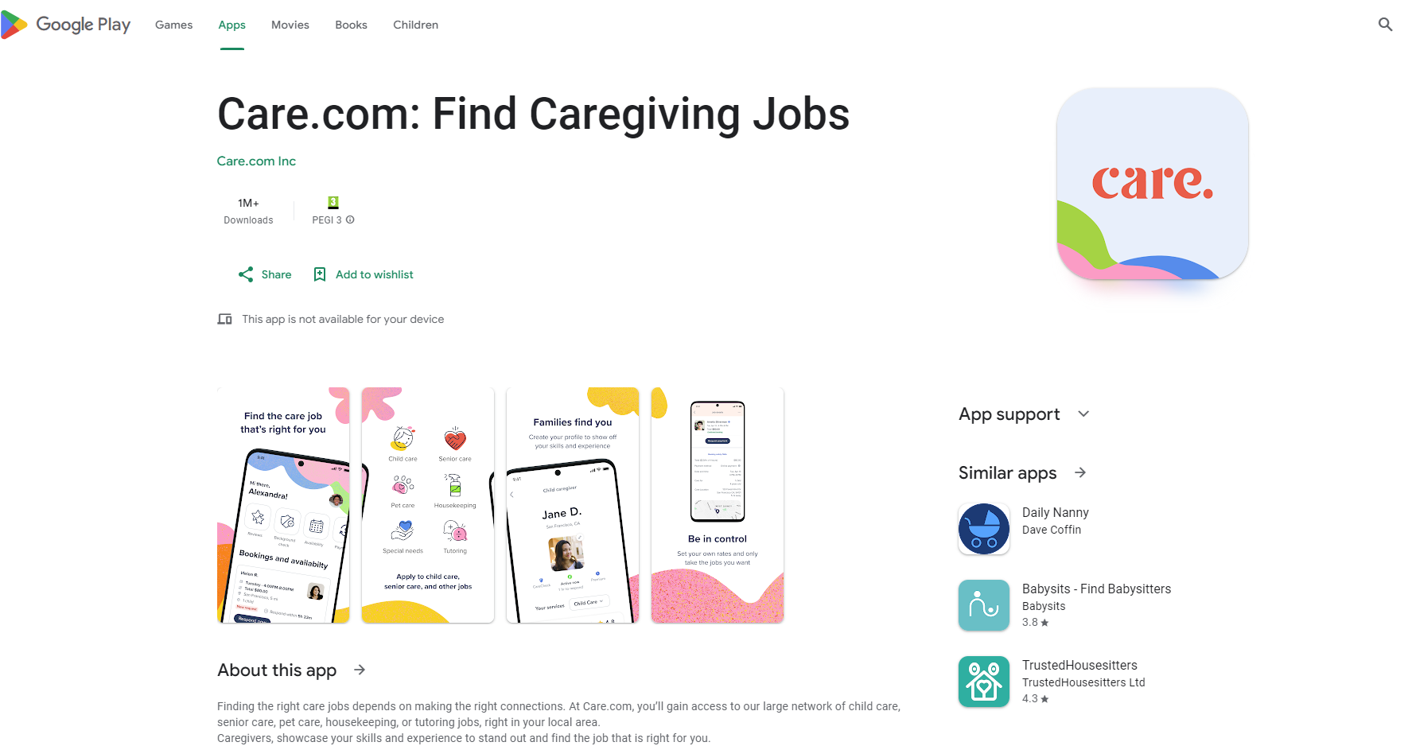

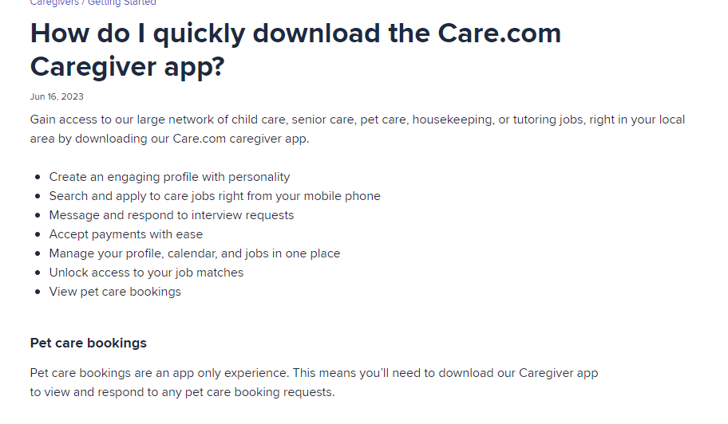

## \* ALHomecare

https://www.alhomecare.ie/about-us

**Email**

[reception@alhomecare.ie](mailto:reception@alhomecare.ie)

**Phone**  
Dublin: [01 513 5564](tel:015135564)

Cork: [021 601 7261](tel:0216017261)

**Mobile all areas:**

[**087 991 6791**](tel:%200879916791) **(Eileen Brady)**

**If the above lines are busy, phone or text**

[**087 744 0729**](tel:0877440729) **(Eileen Corbett)**

**Our phone lines are open 7 days per week.**

If you have any questions, please contact[**Eileen**](tel:0879916791)on 087 991 6791 or [**Tom**](tel:0877440729)on 087 744 0729

* Application only over online forms and no web or mobile app for customer – organisation communication.
* My Homecare IE

https://myhomecare.ie/contact-us/

### **[NurseBuddy](https://myhomecare.ie/nursebuddy-android-app-installation-manual/" \t "_blank)**

NurseBuddy Medical

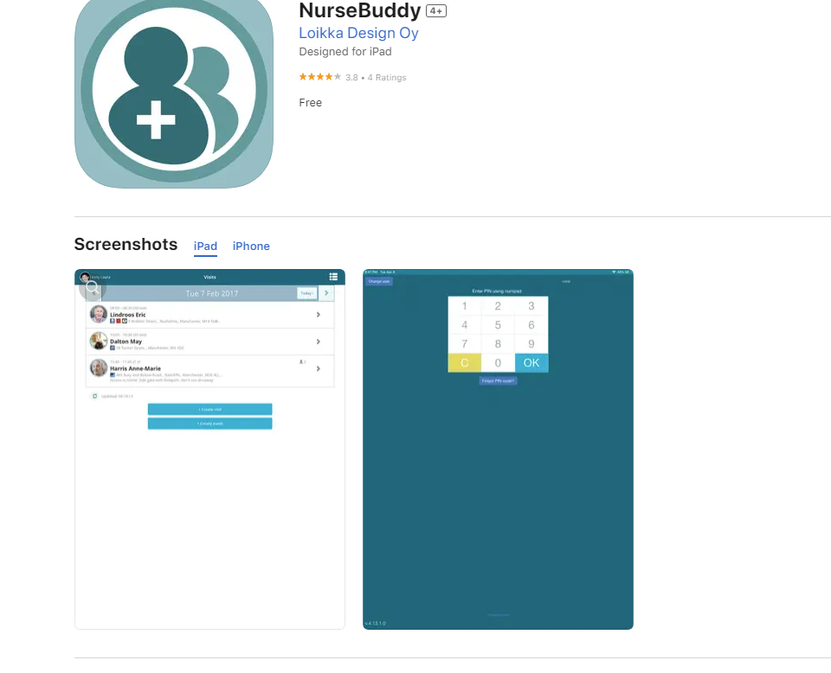

NurseBuddy app is for:

\* care workers / nurses

\* family members

With NurseBuddy care workers and nurses can capture and report important observations in just a few clicks giving each stakeholder involved the ability to follow the status of the person being taken care of.

NurseBuddy

\* Introducing next generation Home Care

\* Real time information about current and forthcoming tasks

Note: Application uses location services for real time task updates and automated reporting. Continued use of GPS running in the background can dramatically decrease battery life. Background positioning will shut down when you log out.

<https://nursebuddy.co/product/>

Creating option of quick and easy reports.   
  
\* no real time health condition check by smart bracelet.   
  
\* no available feedbacks from caring person.

Source of information:   
Log My Care

https://www.logmycare.co.uk/blog/the-top-apps-for-care-assistants

Application:

* Carer App

<https://play.google.com/store/apps/details?id=uk.co.nourishcare.carerapp&hl=en_US>

Management System for daily care for organisations.

* MindMate

<https://www.mindmate-app.com/>

Application that helps people to keep brain in health condition or supports with brain damage.

<https://www.whereyoulivematters.org/best-caregiver-apps/>

<https://www.care.ly/for-families>

https://caringvillage.com/product/  
  
CareVillage – gives option to create personal plan of care with communication option.

